Method resolution order:

,'o'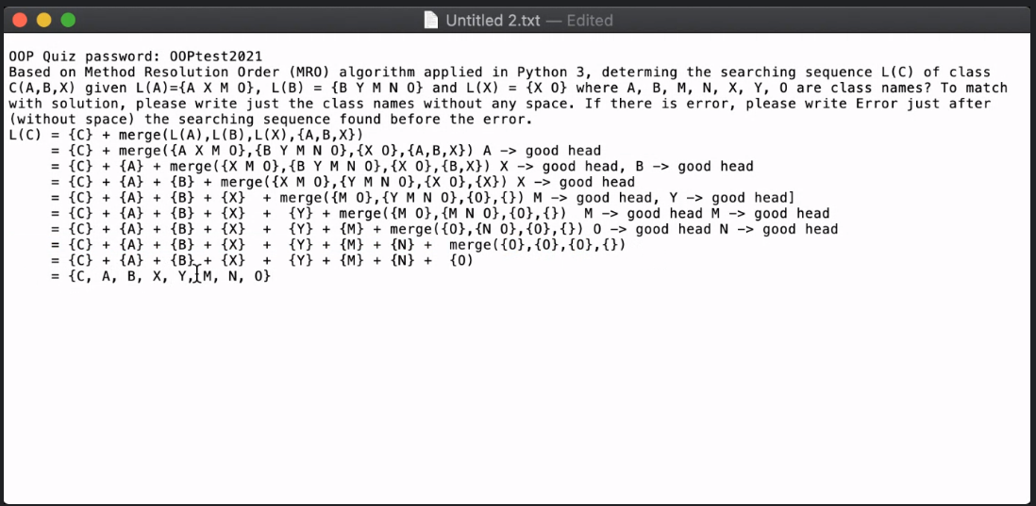

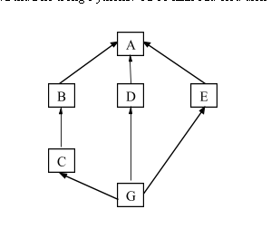

L(A) = {A , O}

L(B) = {B,A,O}

L(C) = {C} + megre(L(B))

= {C} + {B A O}

= {C B A O}

L(D) = {D A O}

L(E) = {E A O}

L(G) = {G} + merge(L(C) , L(D) , L(E))

= {G} + merge({C B A O}, {D A O}, {E A O})

= {G C} + merge ({B A O}, {D A O}, {E A O})

= {G C B} + merge...

= {G C B D } + merge...

= {G C B D E } +merge...

= {G C B D E A O}

ARRAY, OF, COMMA, INT, FLOAT, SIGN, INTLIT, LSB, RSB

array [-1 .. 1,0 .. 1,1 .. 2] of type

array: ARRAY LSB listpara RSB OF typ SEMI;

typ: INT | FLOAT | ARRAY;

listpara: para nextpara;

nextpara: COMMA para nextpara |;

para: SIGN? INLIT '..' SIGN? INLIT;